**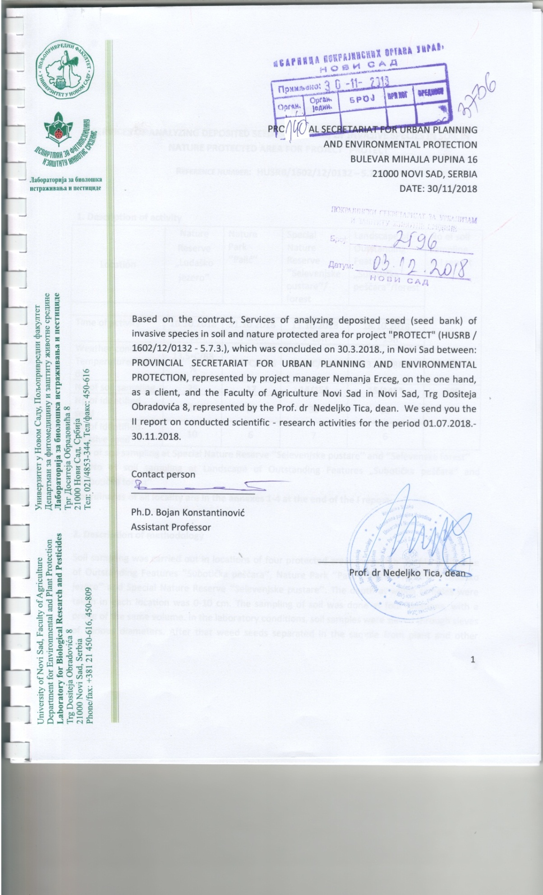**

**II REPORT**

**SERVICES OF ANALYZING DEPOSITED SEED (SEED BANK) OF INVASIVE SPECIES IN SOIL IN NATURE PROTECTED AREA FOR PROJECT “PROTECT”**

**Reference number: HUSRB/1602/12/0132 – 5.7.3.**

**1. Description of activity**

|  |  |  |  |  |  |
| --- | --- | --- | --- | --- | --- |
| Location | Nature Reserve „Ludaško jezero“ | Nature  Park ‘’Palić’’ | Special Nature Reserve ‘’Selevenjske pustare’’/  forest | Landscape of Outstanding Features „Subotička peščara“/forest | No of soil sampling in I report |
|  | | | | |
| Time of activity | 16.10.2018  7-15h | 31.10.2018  7-15h | 11.10.2018  7-15h | 18.10.2018  7-15h |
| Weather condition  Temperature/humidy | 13,5◦C/88% | 12,5◦C/93% | 14,6◦C/89% | 13,8◦C/86% |
| No of soil sampling | 25 | 17 | 14/15\* | 15/14\*\* | 100 |
| No of identified seed | 28 | 19 | 32 | 23 |  |
| No of identified invasive seed | 10 | 6 | 7 | 6 |

\*No of soil sampling at Special Nature Reserve ‘’Selevenjske pustare’’ and ‘’Selevenske forest’’

\*\* No of soil sampling at Landscape of Outstanding Features „Subotička peščara“ and ’’Subotička forest’’

**Coordinates of all locality are in the annexes 1-4 at the end of the I report.**

**2. Description of methodology**

Soil sampling was carried out in locations of four protected areas in north of Serbia Landscape of Outstanding Features ‘’Subotička peščara’’, Nature Park ‘’Palić’’, Nature Reserve ‘’Ludaško jezero’’ and Special Nature Reserve ‘’Selevenjske pustare’’. The depth at which samples were taken in each location was 0-10 cm. The sampling of soil was done at four locations, with a probe of the same volume. In the laboratory conditions, soil samples were sieved through sieves of various diameters. After that weed seeds separated in the sample from plant and other material and the identification of seeds was carried out. Identifying the seeds and determining their quantity was carried out with microscopes and determiners.

Second report shows soil sampling at the end of the first vegetation season.

**3. Results**

**Nature Reserve ‘’Ludaško jezero’’**

At the location of Nature Reserve ‘’Ludaško jezero’’ 28 weed species were identified: *Amaranthus retroflexus, Stellaria media, Setaria italica, Chenopodium hybridum, Trifolium repens, Polygonum aviculare, Datura stramonium, Chenopodium album, Portulace oleracea, Asclepias syriaca, Melilotus officinalis, Daucus carota, Senecio vulgaris, Solanum nigrum, Urtica dioica, Erigeron canadensis, Bromus mollis, Lolioum multiflorum, Ambrosia artemisiifolia, Euphorbia helioscopia, Matricaria discoidea, Raphanus raphanistrum, Canabis sativa, Phragmites communis, Colendula officinalis, Sonchus arvensis, Echinochloa crus-galli* and *Ailanthus altissima* (table 1)*.*

Table 1: Determined weed seeds at Special at Nature Reserve „Ludaško jezero“



SUM- the total number of weed seeds in 25 soil samples at 0-10 depth

no m2 - the total number of weed seeds in all soil samples expressed per m2

The seeds of invasive weeds at the location of Nature Reserve ‘’Ludaško jezero’’ were identified: *Amaranthus retroflexus, Portulaca oleracea, Setaria italica, Datura stramonium, Echinochloa crus-galli, Ambrosia artemisiifolia, Asclepias syriaca, Matricaria discoidea, Ailanthus altissima* and *Lolium multiforum* (Table 1)*.*

Table 2: Determined invasive weed seeds at Special at Nature Reserve „Ludaško jezero“

|  |  |  |
| --- | --- | --- |
| **Weed seeds** | **SUM** | **no m2** |
| *Amaranthus retroflexus* | 169 | 13478,53 |
| *Setaria italica* | 17 | 1355,83 |
| *Datura stramonium* | 12 | 957,06 |
| *Portulaca oleracea* | 69 | 5503,07 |
| *Asclepias syriaca* | 2 | 159,51 |
| *Lolium multiflorum* | 7 | 558,28 |
| *Ambrosia artemisiifolia* | 8 | 638,04 |
| *Matricaria discoidea* | 6 | 478,53 |
| *Echinochloa crus-galli* | 2 | 159,51 |
| *Ailanthus altissima* | 3 | 239,26 |

SUM- the total number of invasive weed seeds in 25 soil samples at 0-10 depth

NO m2 - the total number of invasive weed seeds in all soil samples expressed per m2

The average number of weeds seed per m², at the location Special at Nature Reserve „Ludasko jezero“ , in the soil profil 0-10 cm is in the range of 79,75 to 13.478,53 seeds per m2 respectively. The weed seed bank contain several dominant species in all samples. Like in the spring, again *Amaranthus retroflexus* and *Portulaca oleracea* were one of the most numerous at the locality. *Amaranthus retroflexus* is the weed species with the highest number of selected seed from the samples (13.478,53 seeds per m2), followed by *Portulaca oleracea* (5.503,07 seeds per m2), *Setaria italica* (1.355,83 seeds per m2), *Datura stramonium* (957,06 seeds per m2), *Ambrosia artemisiifolia* (638,04 seeds per m2), *Lolium multiflorum* (558,28 seeds per m2), *Matricaria discoidea* (478,53 seeds per m2), *Ailanthus altissima* (239,26 seeds per m2), *Echinochloa crus-galli* and *Asclepias syriaca* (159,51 seeds per m2).

**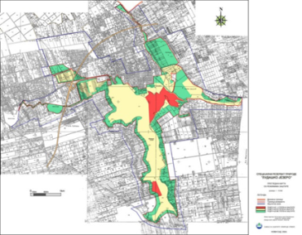** Map 1 – Special Nature Reserve „Ludasko jezero

|  |  |
| --- | --- |
| 20181016_093949.jpg | |
| 20181016_085915.jpg | 20181016_100047.jpg |
| 20181016_082310.jpg | 20181016_083619.jpg |
| Picture 1-5: Sampling of soil atSpecial at Nature Reserve „Ludaško jezero“ | |

**Nature Park „Palić“**

At the location of Nature Park „Palić“, 19 weed species were identified: Chenopodium album, *Amaranthus retroflexus, Portulaca oleracea, Celtis occidentalis, Veronica hederifolia, Polygonum aviculare, Robinia pseudoacacia, Bromus molis,* *Medicago polymorpha, Datura stramonium, Sambucus nigra, Asclepias syriaca, Matricaria chamomilla, Polygonum lapathifolim, Daucus carota, Canabis sativa, Phacelia tanacetifolia, Carduus acanthoides* and *Crataegus monogyna* (table 3).

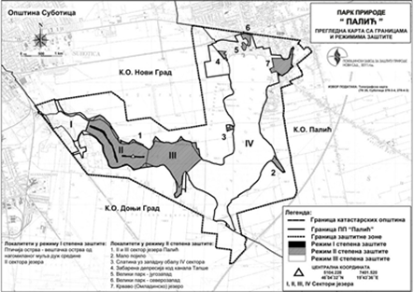

Map 2 – Nature Park „Palić“

The seeds of invasive weeds at the location of Nature Reserve ‘’Ludaško jezero’’ were identified: *Amaranthus retroflexus, Portulacae olaraceae, Celtis occidentalis, Robinia pseudoacacia, Asclepias syriaca* and *Phacelia tanacetifolia* (Table 3)*.*

Table 3: Determined weed seeds at Nature Park „Palic“



SUM- the total number of weed seeds in 25 soil samples at 0-10 depth

no m2 - the total number of weed seeds in all soil samples expressed per m²

|  |  |  |
| --- | --- | --- |
| **Weed seeds** | **SUM** | **no m2** |
| *Amaranthus retroflexus* | 69 | 5503,07 |
| *Portulacae olaraceae* | 20 | 1595,09 |
| *Celtis occidentalis* | 23 | 1834,36 |
| *Robinia pseudoacacia* | 1 | 79,75 |
| *Asclepias syriaca* | 1 | 79,75 |
| *Phacelia tanacetifolia* | 25 | 1993,87 |

Table 4: Determined invasive weed seeds at Nature Park „Palić“

SUM- the total number of invasive weed seeds in 25 soil samples at 0-10 depth

NO m2 - the total number of invasive weed seeds in all soil samples expressed per m²

The average number of weeds at the location Nature Park „Palić“in the soil profil 0-10 cm is in the range of 79,75 to 5503,07 seeds per m2 respectively. The weed seed bank contains several dominant invasive weed species in all samples. *Amaranthus retroflexus* and *Celtis occidentalis* were one of the most numerous at the locality, like in spring this year. *Amaranthus retroflexus* is the weed species with the highest number of selected seed from the samples (5503,07 seeds per m2), followed by *Celtis occidentalis* (1834,36 seeds per m2), *Phacelia tanacetifolia* (1993,87 seeds per m2), *Portulacae olaraceae* (1595,09 seeds per m2), *Asclepias syriaca* and *Robinia pseudoacacia* with 79,75 seeds per m2 (table 4).

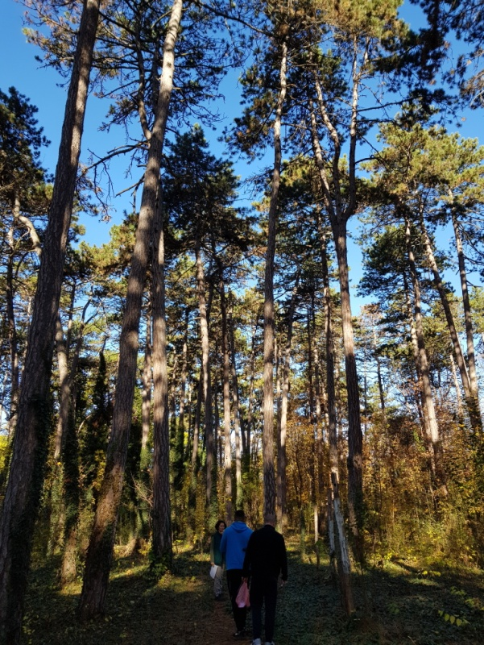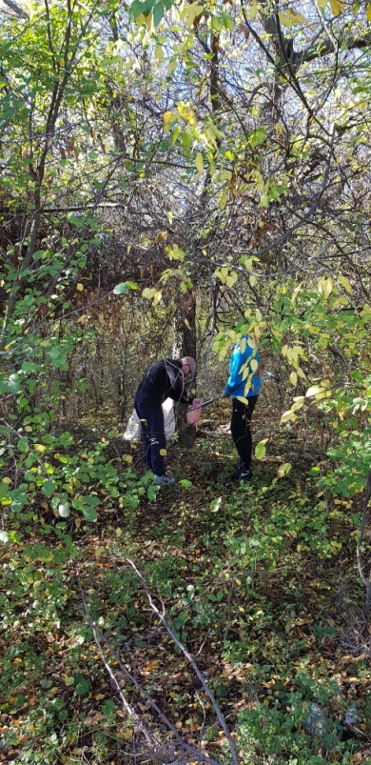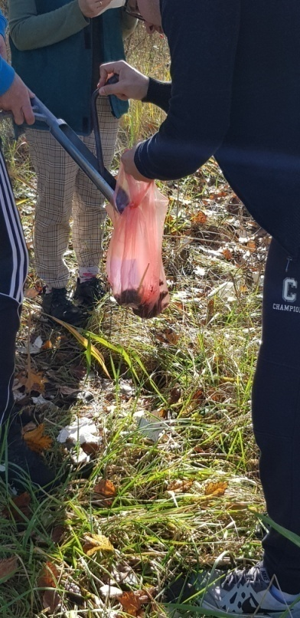

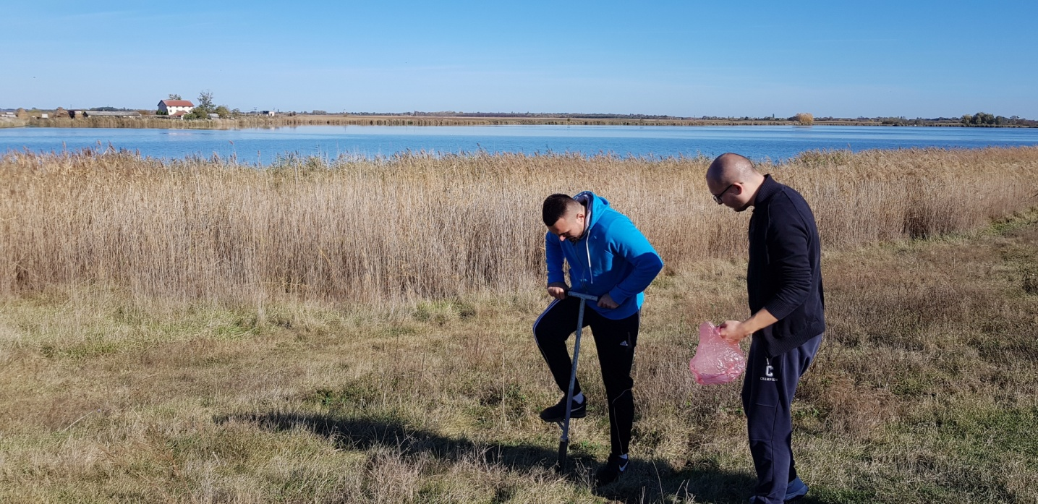

Picture 6-9: Sampling of soil atSpecial at Nature Park „Palić“

**Special Nature Reserve „Selevenjske pustare“**

At the location of Special Nature Reserve „Selevenjske pustare“ studied 32 weed species were identified: *Vicia cracca, Chenopodium hybridum, Portulaca oleracea, Polygonum aviculare, Lepidium draba, Setaria italica, Poa trivialis, Matricaria inodora, Raphanus raphanistrum, Datura stramonium, Canabis sativa, Amaranthus retrofelxus, Daucus carota, Sonchus oleraceus, Chenopodium album, Centaurea adleriana, Amrbosia artemisiifolia, Bromus molis, Medicago polymorpha, Veronica hederifolia, Solanum nigrum, Melilothus officinalis, Celtis occidentalis, Sambucus nigra, Stellaria media, Robinia pseudoacacia, Mysotis arvensis, Lithosperum officinale, Bilderdykia convolvulus, Urtica dioica, Dianthus sp.* and *Silene alba* (table 5)*.*

**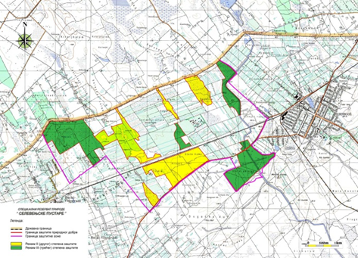**

Map 3 - Special Nature Reserve „Selevenjske pustare“

The seeds of invasive weeds at the location of Special Nature Reserve „Selevenjske pustare“ were identified*: Portulaca oleracea, Setaria italica, Datura stramonium, Amaranthus retrofelxus, Amrbosia artemisiifolia, Celtis occidentalis* and *Robinia pseudoacacia* (table 6)*.*

Table 5: Determined weed seeds at Special Nature Reserve „Selevenjske pustare“



F-forest

SUM- the total number of weed seeds in 25 soil samples at 0-10 depth

NO m2 - the total number of weed seeds in all soil samples expressed per m2

The average number of weeds at the location Special Nature Reserve „Selevenjske pustare“in the soil profil 0-10 cm is in the range of 79,75 to 16.030,67 seeds per m2 respectively. The weed seed bank contains several dominant invasive weed species in all samples. Again, *Amaranthus retroflexus* and *Portulaca oleracea* were one of the most numerous at the locality. *Amaranthus retroflexus* is the weed species with the highest number of selected seed from the samples (16.030,67 seeds per m2), followed by *Portulaca oleracea* (5.742,33 seeds per m2), *Celtis occidentalis* (1.435,58 seeds per m2), *Setaria italica* (1.276,07 seeds per m2), *Robinia pseudoacacia* (558,28 seeds per m2), *Datura stramonium* and *Ambrosia artemisiifolia* (159,51 seeds per m2), *(*table 6).

Table 6: Determined invasive weed seeds at Special Nature Reserve „Selevenjske pustare“

|  |  |  |
| --- | --- | --- |
| **Weed seeds** | **SUM** | **no m2** |
| *Portulacae olaraceae* | 72 | 5.742,33 |
| *Setaria italica* | 16 | 1.276,07 |
| *Datura stramonium* | 2 | 159,51 |
| *Amaranthus retroflexus* | 201 | 16.030,67 |
| *Ambrosia artemisiifolia* | 2 | 159,51 |
| *Celtis occidentalis* | 18 | 1.435,58 |
| *Robinia pseudoacacia* | 7 | 558,28 |

SUM- the total number of invasive weed seeds in 25 soil samples at 0-10 depth

NO m2 - the total number of invasive weed seeds in all soil samples expressed per m2

**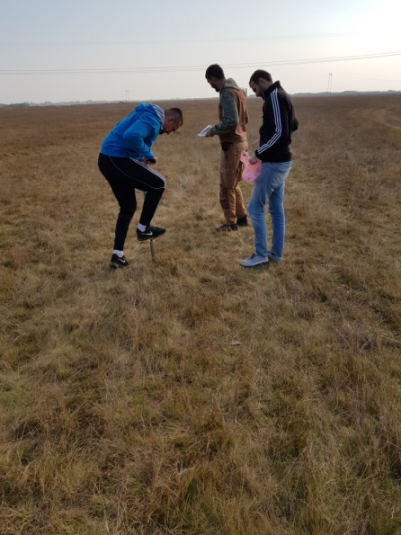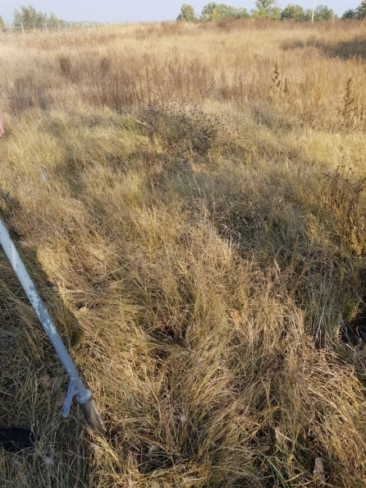**

**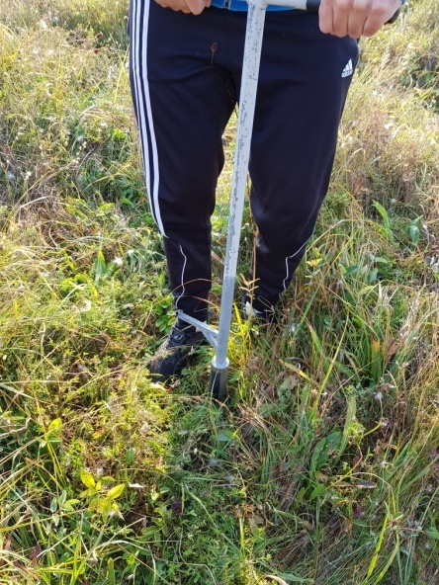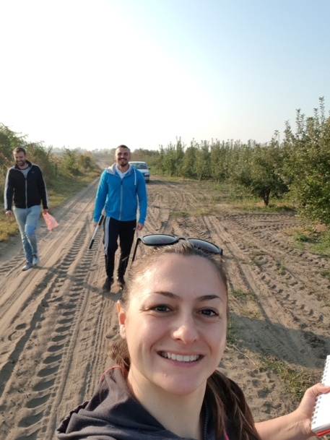**

Picture 10-13: Sampling of soil atSpecial Nature Reserve „Selevenjske pustare“

**Landscape of Outstanding Features „Subotička peščara“**

At the location of Landscape of Outstanding Features „Subotička peščara“ studied 23 weed species were identified: *Amaranthus retroflexus, Portulaca oleracea, Polygonum aviculare, Rapahanus raphanistrum, Setaria italica, Delphinium consolida, Chenopodium album, Chenopodium hybridum, Polygonum lapathifolium, Ambrosia artemisiifolia, Celtis occidentale, Sambucus nigra, Medicago polymorpha, Bromus spp., Canabis sativa, Trifolium repens, Iva xantihifolia, Calendula officinalis, Veronica hederifolia, Lolium multiflorum, Robinia pseudoacacia, Salvia officinalis* and *Rumex crispus* (table 5)*.*

**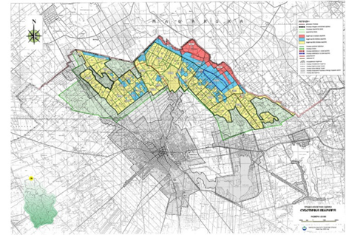**

Map 4 - Landscape of Outstanding Features „Subotička peščara“

The seeds of invasive weeds at the location of Landscape of Outstanding Features „Subotička peščara“ were identified: *Amaranthus retroflexus*, *Echinochloa crus-galli*, *Setaria italica*, *Celtis occidentialis*, *Robinia pseudoacacia, Erodium ciconium*, *Asclepias syriaca* (table 6)*.*

Table 5: Determined weed seeds at Landscape of Outstanding Features „Subotička peščara“



F-forest

SUM- the total number of weed seeds in 25 soil samples at 0-10 depth

NO m2 - the total number of weed seeds in all soil samples expressed per m2

The average number of weeds at the location Landscape of Outstanding Features „Subotička peščara“ in the soil profil 0-10 cm is in the range of 79,75 to 17.785,28 seeds per m2 respectively. The weed seed bank contains several dominant invasive species in all samples. *Celtis occidentalis* and *Amaranthus retroflexus* were one of the most numerous at the locality. *Amaranthus retroflexus* is the weed species with the highest number of selected seed from the samples (17.785,28 seeds per m2), followed by *Celtis occidentalis* (3.269,94 seeds per m2), *Setaria italica* (2.631,90 seeds per m2), *Ambrosia artemisiifolia* and *Iva xanthifolia* had same number of determinate weed seeds 159,51 seeds per m2 (table 8).

Table 8: Determined invasive weed seeds at Landscape of Outstanding Features „Subotička peščara“

|  |  |  |
| --- | --- | --- |
| **Weed seeds** | **SUM** | **no m2** |
| *Amaranthus retroflexus* | 223 | 17.785,28 |
| *Celtis occidentialis* | 41 | 3.269,94 |
| *Setaria italica* | 33 | 2.631,90 |
| *Ambrosia artemisiifolia* | 2 | 159,51 |
| *Iva xanthifolia* | 2 | 159,51 |

SUM- the total number of invasive weed seeds in 25 soil samples at 0-10 depth

NO m2 - the total number of invasive weed seeds in all soil samples expressed per m2

Analyzing deposited seed (seed bank) of invasive species in soil is made in the representative locations of four protected areas in the north of Serbia Landscape of Outstanding Features „Subotička peščara“, Nature Park „Palić“, Special Nature Reserve „Ludaško jezero“ and Special Nature Reserve „Selevenjske pustare“. In the table below (table 9) presents the determined seed invasive weeds tested at 4 protected areas. There was a very large number of weed seeds a few weed species. At four studied areas, presence of a large number of seeds of the following weed species was determined: *Amaranthus retroflexus, Celtis occidentalis, Portulacae olaraceae, Setaria italica*. Other weed species were also determined with large numbers of seed in soil, with more or less seeds in the samples.

Table 9: Number of invasive weed seed per m2 for all 4 protected areas

|  |  |  |  |  |
| --- | --- | --- | --- | --- |
| **Invasive weed seeds** | **SNRLJ1** | **NPP2** | **SNRSP3** | **LOFSP4** |
| *Amaranthus retroflexus* | 13.478,53 | 5.503,07 | 16.030,67 | 17.785,28 |
| *Setaria italica* | 1.355,83 | - | 1.276,07 | 2.631,90 |
| *Datura stramonium* | 957,06 | - | 159,51 | - |
| *Portulaca oleracea* | 5.503,07 | 1.595,09 | 5.742,33 | - |
| *Asclepias syriaca* | 159,51 | 79,75 | - | - |
| *Lolium multiflorum* | 558,28 | - | - | - |
| *Ambrosia artemisiifolia* | 638,04 | - | 159,51 | 159,51 |
| *Matricaria discoidea* | 478,53 | - | - | - |
| *Echinochloa crus-galli* | 159,51 | - | - | - |
| *Ailanthus altissima* | 239,26 | - | - | - |
| *Celtis occidentialis* | - | 1.834,36 | 1.435,58 | 3.269,94 |
| *Iva xanthifolia* | - | - | - | 159,51 |
| *Robinia pseudoacacia* | - | 79,75 | 558,28 | - |
| *Phacelia tanacetifolia* | - | 1.993,87 | - | - |

**1SNRLJ** - Special Nature Reserve „Ludaško jezero“

**2NPP** - Nature Park „Palić“

**3SNRSP** - Special Nature Reserve „Selevenjske pustare“

**4LOFSP** - Landscape of Outstanding Features „Subotička peščara“

**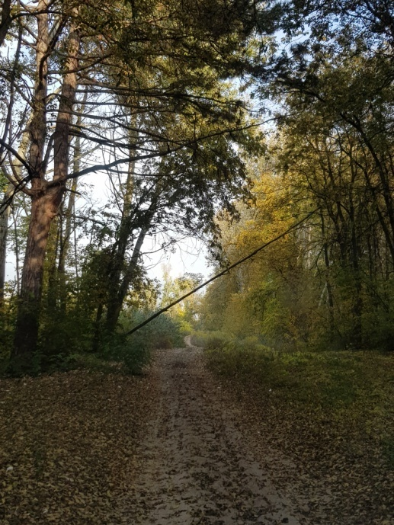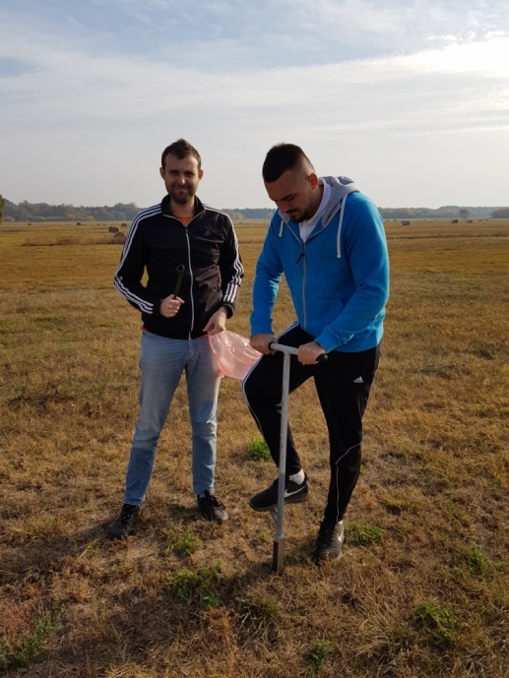**

**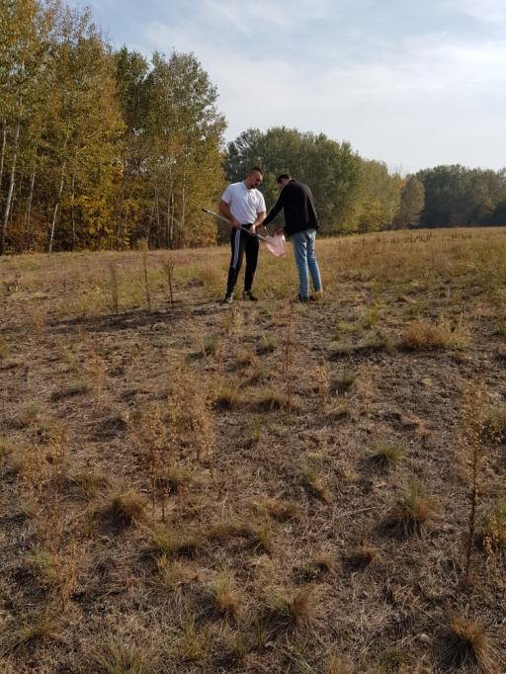 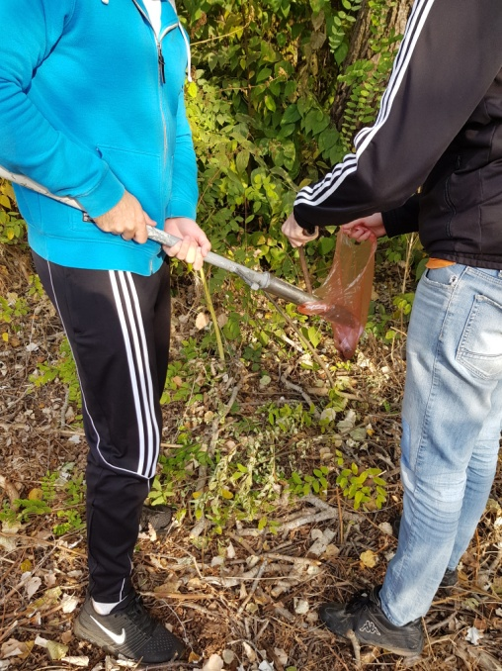**

Picture 14-17: Sampling of soil atLandscape of Outstanding Features „Subotička peščara“

**4. Comments / conclusions**

Analyzing deposited seed (seed bank) of invasive species in soil in nature proteted areawere conducted in the representative locations of four protected areas in the north of Serbia Landscape of Outstanding Features „Subotička peščara“, Nature Park „Palic“, Special Nature Reserve „Ludasko jezero“ and Special Nature Reserve „Selevenjske pustare“. At all four protected location is determined 14 different seeds of invasive weed species. *Amaranthus retroflexus* was determinated on every examined area.

*Amaranthus retroflexus, Celtis occidentalis,* Portulaca oleracea and *Setaria italic* were determinated in very large numbers at almost every protected location.

*Ambrosia artemisiifolia* was determinate in large numbers at Special Nature Reserve „Ludaško jezero“,Landscape of Outstanding Features „Subotička peščara“ and Special Nature Reserve „Selevenjske pustare“.

Contact person

\_\_\_\_\_\_\_\_\_\_\_\_\_\_\_\_\_\_\_\_\_\_\_\_

Ph.D. Bojan Konstantinović

Assistant Professor

Annexe 1. Nature Reserve „Ludaško jezero“

|  |  |  |  |
| --- | --- | --- | --- |
| No of soil sampling | GPS coordinates | No of soil sampling | GPS coordinates |
| 1 | 46°5'47''  19°47'37'' | 14 | 46°5'47''  19°47'37'' |
| 2 | 46°6'21''  19°49'8'' | 15 | 46°6'19''  19°51'30'' |
| 3 | 46°5'47''  19°47'37'' | 16 | 46°6'37''  19°49'41'' |
| 4 | 46°5'15''  19°47'4'' | 17 | 46°6'10''  19°50'37'' |
| 5 | 46°5'47''  19°47'4'' | 18 | 46°6'19''  19°51'30'' |
| 6 | 46°6'20''  19°47'51'' | 19 | 46°6'46''  19°49'58'' |
| 7 | 46°5'47''  19°49'40'' | 20 | 46°6'50''  19°50'50'' |
| 8 | 46°6'04''  19°42'47'' | 21 | 46°6'59''  19°49'31'' |
| 9 | 46°5'34''  19°50'0'' | 22 | 46°6'34''  19°48'53'' |
| 10 | 46°5'18''  19°49'57'' | 23 | 46°6'59''  19°49'31'' |
| 11 | 46°5'18''  19°49'56'' | 24 |  |
| 12 | 46°5'37''  19°49'41'' | 25 |  |
| 13 | 46°6'30''  19°49'29'' |  | |

Annexe 2. Nature Park ‘’Palić’’

|  |  |  |  |
| --- | --- | --- | --- |
| No of soil sampling | GPS coordinates | No of soil sampling | GPS coordinates |
| 1 | 46°05'912''  19°46’60’’ | 11 | 46°04'376''  19°46'119'' |
| 2 | 46°05'92''  19°45'60'' | 12 | 46°04'225''  19°44'267'' |
| 3 | 46°06'008''  19°45'46'' | 13 | 46°04'198''  19°44'258'' |
| 4 | 46°06'089''  19°45'37'' | 14 | 46°04'367''  19°43'602'' |
| 5 | 46°06'058''  19°45'272'' | 15 | 46°04'349''  19°43'517'' |
| 6 | 46°05'895''  19°44'912'' | 16 | 46°04'368''  19°43'555'' |
| 7 | 46°05'904''  19°44'978'' | 17 | 46°04'565''  19°42'371'' |
| 8 | 46°05'626''  19°45'105'' |  | |
| 9 | 46°05'805''  19°44'975'' |
| 10 | 46°04'385''  19°46'141'' |

Annexes 3. Special Nature Reserve ‘’Selevenjske pustare’’/ forest

|  |  |  |  |
| --- | --- | --- | --- |
| Soil sampling in ’Selevenjske pustare’’ | | Soil sampling in ``Selevenjske forest‚‚ | |
| No of soil sampling | GPS coordinates | No of soil sampling | GPS coordinates |
| 1 | N46 04 34.9  E19 42 23.8 | 1F | N46 08 20.0  E19 53 12.2 |
| 2 | N46 07 37.1 E19 53 58.0 | 2F | N46 08 21.1  E19 53 09.1 |
| 3 | N46 07 53.3 E19 54 21.2 | 3F | N46 08 30.7  E19 53 15.0 |
| 4 | N46 08 21.4 E19 55 10.8 | 4F | N46 08 37.7  E19 53 06.8 |
| 5 | N46 08 09.5 E19 55 55.8 | 5F | N46 08 39.4  E19 53 14.3 |
| 6 | N46 07 56.2 E19 56 12.4 | 6F | N46 08 39.6  E19 53 14.1 |
| 7 | N46 09 19.8 E19 55 47.0 | 7F | N46 08 44.4  E19 53 09.6 |
| 8 | N46 09 48.5 E19 55 36.5 | 8F | N46 08 41.7  E19 53 20.9 |
| 9 | N46 08 42.3 E19 54 22.5 | 9F | N46 08 53.9  E19 53 12.7 |
| 10 | N46 09 37.9 E19 54 17.2 | 10F | N46 08 34.1  E19 52 32.9 |
| 11 | N46 08 42.0 E19 54 22.5 | 11F | N46 08 44.1  E19 52 29.6 |
| 12 | N46 08 42.4 E19 52 06.3 | 12F | N46 08 46.2  E19 52 30.2 |
| 13 | N46 08 59.0 E19 52 03.7 | 13F | N46 08 50.4  E19 52 40.4 |
| 14 | N46 08 30.0 E19 51 39.3 | 14F | N46 08 52.8  E19 52 45.4 |
|  | | 15F | N46 08 55.4  E19 52 54.5 |

Annexes 4. Landscape of Outstanding Features „Subotička peščara“/forest

|  |  |  |  |
| --- | --- | --- | --- |
| Soil sampling in ``Subotička peščara‚‚ | | Soil sampling in ``Subotička forest‚‚ | |
| No of soil sampling | GPS coordinates | No of soil sampling | GPS coordinates |
| 1 | N46 08 50.8 E19 45 17.5 | 1F | N46 07 27.5  E19 47 00.4 |
| 2 | N46 09 20.9 E19 44 18.5 | 2F | N46 07 24.2  E19 46 12.5 |
| 3 | N46 09 19.4 E19 44 16.6 | 3F | N46 07 45.9  E19 45 50.2 |
| 4 | N46 09 27.4 E19 44 20.0 | 4F | N46 08 44.0  E19 44 52.9 |
| 5 | N46 09 49.2 E19 44 15.2 | 5F | N46 08 00.1  E19 44 24.2 |
| 6 | N46 09 52.3 E19 44 18.4 | 6F | N46 07 59.9  E19 44 14.8 |
| 7 | N46 09 52.7 E19 44 21.1 | 7F | N46 09 27.6  E19 43 10.9 |
| 8 | N46 09 46.7 E19 43 40.8 | 8F | N46 09 48.4  E19 42 53.1 |
| 9 | N46 09 52.7 E19 44 21.1 | 9F | N46 09 48.5  E19 42 53.1 |
| 10 | N46 09 59.4 E19 43 28.5 | 10F | N46 09 08.3  E19 39 00.0 |
| 11 | N46 09 57.5 E19 43 28.7 | 11F | N46 09 25.1  E19 38 18.6 |
| 12 | N46 09 54.6 E19 43 22.8 | 12F | N46 08 39.7  E19 37 28.8 |
| 13 | N46 10 18.0 E19 42 39.8 | 13F | N46 09 37.8  E19 36 23.3 |
| 14 | N46 10 06.3 E19 42 34.7 | 14F | N46 09 09.7  E19 34 58.0 |
| 15 | N46 10 06.2 E19 42 34.8 |  | |